

**GOVERNMENT OF TAMILNADU**

DIRECTORATE OF TECHNICAL EDUCATION, CHENNAI

NAAN MUDHALVAN SCHEME (TNSDC) SPONSORED

STUDENTS DEVELOPMENT PROGRAMME

ON

**IoT AND ITS APPLICATIONS**

**“SMART DUSTBIN SYSTEM”**

**HOST INSTITUTION**

XXXX

DISTRICT - PINCODE

**TRAINING PARTNER**

**ENTHU TECHNOLOGY SOLUTIONS INDIA PVT LTD**

**DATE:**

|  |  |
| --- | --- |
| **NAME** | **ROLL NO** |
| Name 1 |  |
| Name 2 |  |
| Name 3 |  |
| Name 4 |  |
| Name 5 |  |
| Name 6 |  |

**Table of Contents**

|  |  |  |
| --- | --- | --- |
| **S No** | **Title** | **Page No** |
| **1** | **Abstract** | **1** |
| **2** | **Introduction** | **2** |
| **3** | **Components** | **2** |
| **4** | **Circuit Diagram** | **7** |
| **5** | **Code** | **8** |
| **6** | **Output Results** | **12** |
| **7** | **Cloud Output** | **13** |
| **8** | **Conclusion** | **14** |
| **9** | **Reference** | **15** |

**SMART DUSTBIN SYSTEM**

**ABSTRACT**

The Smart Dustbin System is an innovative Internet of Things (IoT) solution designed to improve waste management in office environments. The system is built around an ESP32 microcontroller and incorporates two infrared (IR) sensors. The first sensor is responsible for detecting the presence of a person near the dustbin, while the second sensor monitors the fill level of the dustbin to determine whether it is full. When the system detects a person and the dustbin is not full, it automatically triggers a motor that opens the dustbin lid, allowing for hands-free waste disposal. This feature enhances hygiene and convenience in high-traffic areas such as offices. Additionally, the system is equipped with WiFi connectivity, enabling it to communicate with a remote server via HTTP. The status of the dustbin—whether a person is detected and whether the bin is full—is transmitted to the server in real-time. This data can be used for monitoring purposes, ensuring that the dustbin is emptied promptly when full and reducing the need for manual checks. Overall, the Smart Dustbin System offers an efficient, hygienic, and modern approach to waste management, leveraging IoT technology to streamline operations and improve workplace cleanliness.

**INTRODUCTION**

In modern office environments, maintaining cleanliness and hygiene is crucial for ensuring a healthy and productive workspace. Traditional waste management practices often involve manual checks to determine when a dustbin needs to be emptied, which can be inefficient and prone to oversight. To address this challenge, the Smart Dustbin System offers an automated solution that leverages the power of the Internet of Things (IoT). This system is designed to enhance waste management by integrating an ESP32 microcontroller with two infrared (IR) sensors and a motorized lid. The sensors detect the presence of a person and monitor the fill level of the dustbin, while the motor automatically opens the lid for hands-free disposal. Additionally, the system's WiFi connectivity allows it to send real-time status updates to a remote server, enabling more efficient monitoring and timely maintenance. This innovative approach not only improves hygiene but also reduces the need for manual intervention, making it an ideal solution for modern offices.

**Components**

1. ESP32 Microcontroller
2. Arduino IDE
3. IR Sensor
4. Servo Motor
5. USB Cable (B-Type)
6. Breadboard
7. Jumper Wire

**Hardware Description**

**i) ESP32**

The ESP32 is a highly versatile microcontroller developed by Espressif Systems, designed for a wide range of applications, particularly in the Internet of Things (IoT) space. It is renowned for its combination of high performance, integrated wireless connectivity, and a rich set of features, all at a low cost. The ESP32 is commonly used in projects that require both Wi-Fi and Bluetooth capabilities, making it suitable for smart home devices, sensor networks, and wearable technology.

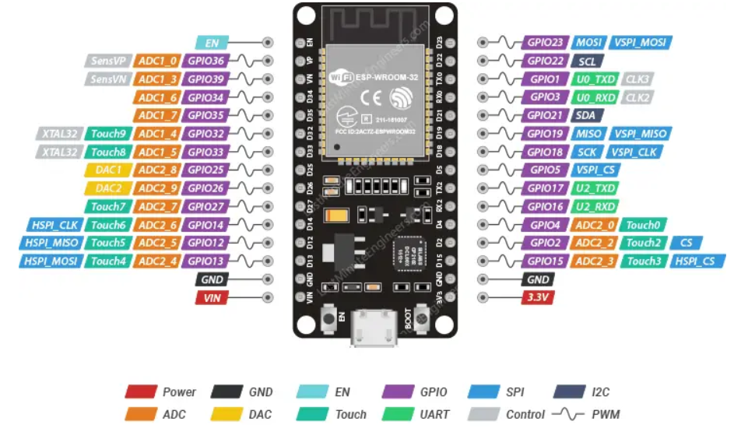

**Figure 1.1**

**Key Features**

* **Dual-Core Processor**: Features a dual-core Tensilica LX6 microprocessor running up to 240 MHz.
* **Connectivity**: Includes Wi-Fi (802.11 b/g/n) and Bluetooth (Classic and BLE).
* **Memory**: Typically comes with 520 KB of SRAM and supports external flash memory.
* **I/O Pins**: Offers numerous GPIO (General Purpose Input/Output) pins with various functionalities.
* **Peripherals**: Includes ADC, DAC, PWM, SPI, I2C, UART, and more.
* **Power Management**: Equipped with low-power modes for energy efficiency.

**ii) IR Sensor**

An Infrared (IR) sensor is an electronic device that detects and measures infrared radiation, typically emitted from an object. It consists of an IR LED that emits infrared light and a photodiode that receives it. When an object passes in front of the sensor, the IR light reflects back, and the photodiode detects the reflected light, triggering a response. IR sensors are widely used in various applications, including motion detection, proximity sensing, and object counting. They are valued for their simplicity, low cost, and ability to operate in low-light conditions. In projects like smart dustbins and drainage systems, IR sensors detect the presence of objects or water levels.

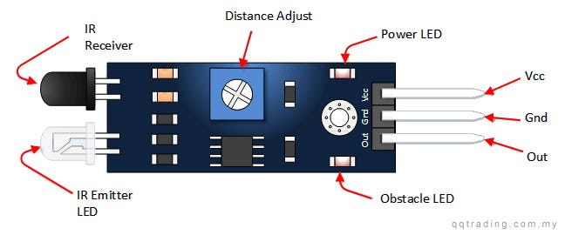

**Figure 1.2**

**Key specifications:**

* **Detection Range:** Up to 7 meters
* **Detection Angle:** 110 degrees
* **Operating Voltage:** DC 4.5V - 12V
* **Output Signal:** 3.3V digital output
* **Delay Time:** Adjustable from 0.3 seconds to 5 minutes
* **Operating Temperature:** -15°C to +70°C
* **Sensitivity:** Adjustable

**iii) Servo Motor**

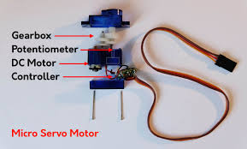A servo motor used with the ESP32 is a compact, precise actuator commonly employed in projects requiring controlled motion, such as robotics, automation, and smart systems. It operates using Pulse Width Modulation (PWM) to set the position of the motor shaft, typically ranging from 0 to 180 degrees. The servo motor has three wires: power, ground, and control, making it easy to interface with the ESP32. Operating at 4.8V to 6V, it offers torque sufficient for small to medium loads. Its precise control and ease of use make it ideal for applications like opening and closing mechanisms, robotic arms, and pan-tilt modules.

**Figure 1.3 Servo Motor**

**Key Features**

* **Operating Voltage:** 4.8V - 6V DC
* **Torque:** 1.5 kg.cm to 3.5 kg.cm (varies by model)
* **Rotation Range:** 0 to 180 degrees
* **Control Signal:** PWM (Pulse Width Modulation)
* **Pulse Width Range:** 1000µs to 2000µs
* **Operating Speed:** 0.1 to 0.2 seconds per 60 degrees (varies by voltage)
* **Gear Type:** Plastic or metal gears
* **Connector Type:** 3-pin (VCC, GND, PWM signal)
* **Operating Temperature**: -10°C to +50°C

**Circuit Diagram**

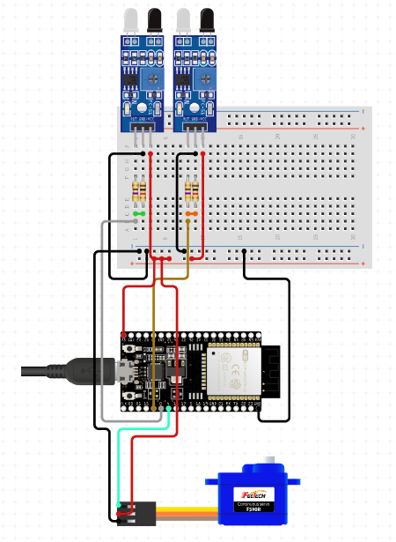

**Figure 1.4 Circuit Diagram**

**SOFTWARE DESCRIPTION**

**ARDUINO IDE**

The Arduino Integrated Development Environment (IDE) is a powerful and user-friendly software application designed to facilitate the programming and uploading of code to Arduino microcontroller boards. It serves as the primary interface for developing, compiling, and debugging Arduino sketches (programs), making it an essential tool for anyone working with Arduino hardware.

* **Simple Interface:** User-friendly and intuitive design, suitable for beginners and experts.
* **Cross-Platform:** Available for Windows, macOS, and Linux.
* **Board Support:** Compatible with various Arduino boards (Uno, Nano, Mega, etc.).
* **Built-in Libraries:** Extensive libraries for sensors, displays, motors, and more.
* **Serial Monitor:** Tool for real-time communication and debugging via serial data.
* **Sketch Management:** Easily manage, save, and organize Arduino sketches (programs).
* **Library Manager:** Browse, install, and manage external libraries effortlessly.
* **Basic Debugging Tools:** Includes Serial Monitor and error indicators.
* **Easy Compilation & Uploading:** Simple process to compile and upload code to the board.
* **Extensible:** Supports third-party plugins for additional features.
* **Beginner-Friendly:** Ideal for those new to microcontrollers and electronics.
* **Open Source:** Free to use, modify, and share, encouraging innovation.
* **Continuous Updates:** Regular improvements and new features from the Arduino team.
* **Versatile Applications:** Suitable for a wide range of projects, from simple to complex.

**CODE**

#include <WiFi.h>

#include <HTTPClient.h>

#include <ESP32Servo.h>

// WiFi credentials

#define WIFI_SSID "iPhone 12"

#define WIFI_PASSWORD "11223344"

// Server details

const char *serverUrl = "https://console.thingzmate.com/api/v1/device-types/sds001/devices/sds001/uplink"; // Replace with your server endpoint

String AuthorizationToken = "Bearer 4f66717ee08ce2b90ef9c51d8fa746d7";

// Pin definitions

#define PERSON_IR_SENSOR_PIN 12 // IR sensor to detect a person

#define FULL_IR_SENSOR_PIN 13   // IR sensor to detect if dustbin is full

#define SERVO_PIN 14            // Servo motor to open/close dustbin

Servo myServo;  // Create a Servo object

int openCount = 0;  // Counter to track the number of times the dustbin has opened

void setup() {

  Serial.begin(115200);

  // Initialize the sensors and servo pin

  pinMode(PERSON_IR_SENSOR_PIN, INPUT);

  pinMode(FULL_IR_SENSOR_PIN, INPUT);

  myServo.attach(SERVO_PIN); // Attach the servo to the defined pin

  myServo.write(0); // Ensure the servo starts in the closed position

  // Connect to WiFi

  WiFi.begin(WIFI_SSID, WIFI_PASSWORD);

  Serial.print("Connecting to WiFi");

  while (WiFi.status() != WL_CONNECTED) {

    delay(1000);

    Serial.print(".");

  }

  Serial.println("Connected to WiFi");

}

void loop() {

  // Read sensor values

  int personDetected = digitalRead(PERSON_IR_SENSOR_PIN);

  int dustbinFull = digitalRead(FULL_IR_SENSOR_PIN);

  // Servo control based on sensor readings

  if (personDetected == HIGH && dustbinFull == LOW) {

    myServo.write(90);  // Open the dustbin by rotating the servo to 90 degrees

    openCount++;  // Increment the open count

    Serial.println("Person detected. Opening dustbin...");

    delay(3000); // Keep the dustbin open for 3 seconds

    myServo.write(0);   // Close the dustbin by rotating the servo back to 0 degrees

    Serial.println("Closing dustbin...");

  } else if (dustbinFull == HIGH) {

    Serial.println("Dustbin is full. Please empty it.");

  }

  // Prepare data for transmission

  String payload = "{\"open_count\":" + String(openCount) + ",\"dustbin_full\":" + String(dustbinFull) + "}";

  // Send data to server

  HTTPClient http;

  http.begin(serverUrl);

  http.addHeader("Content-Type", "application/json");

  http.addHeader("Authorization", AuthorizationToken);

  int httpResponseCode = http.POST(payload);

  if (httpResponseCode > 0) {

    String response = http.getString();

    Serial.println("HTTP Response code: " + String(httpResponseCode));

    Serial.println(response);

  } else {

    Serial.print("Error code: ");

    Serial.println(httpResponseCode);

  }

  http.end(); // Free resources

  delay(3000); // Wait for 10 seconds before sending the next update

}

**OUTPUT**

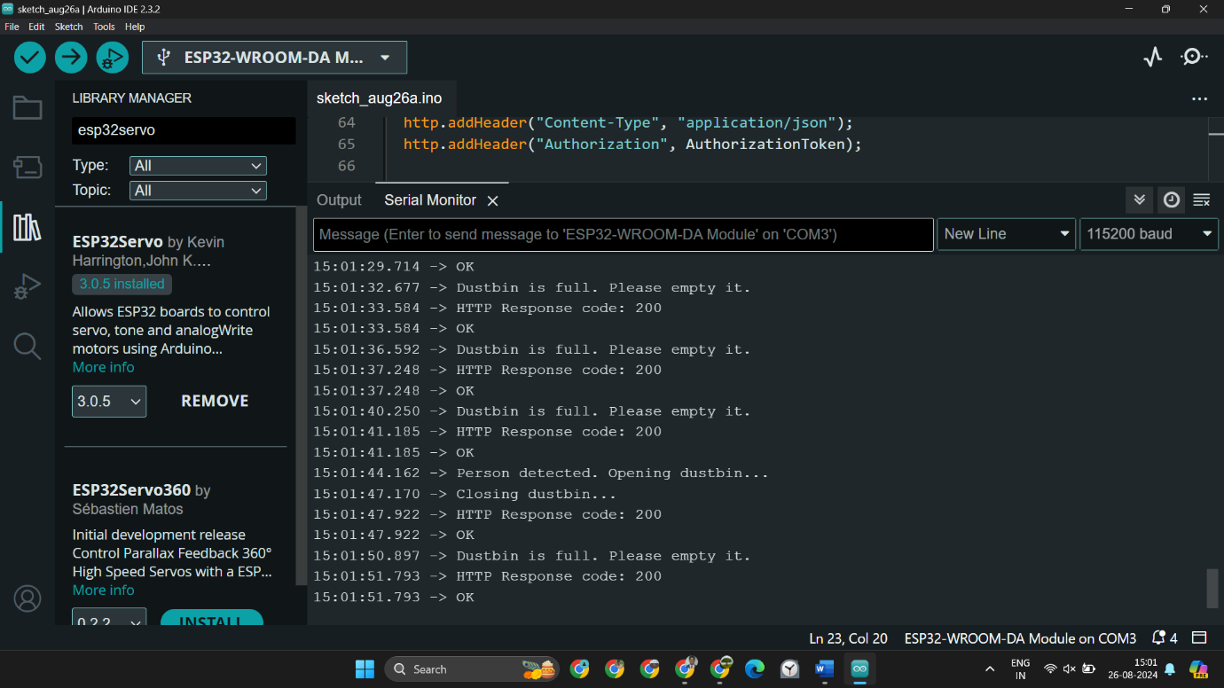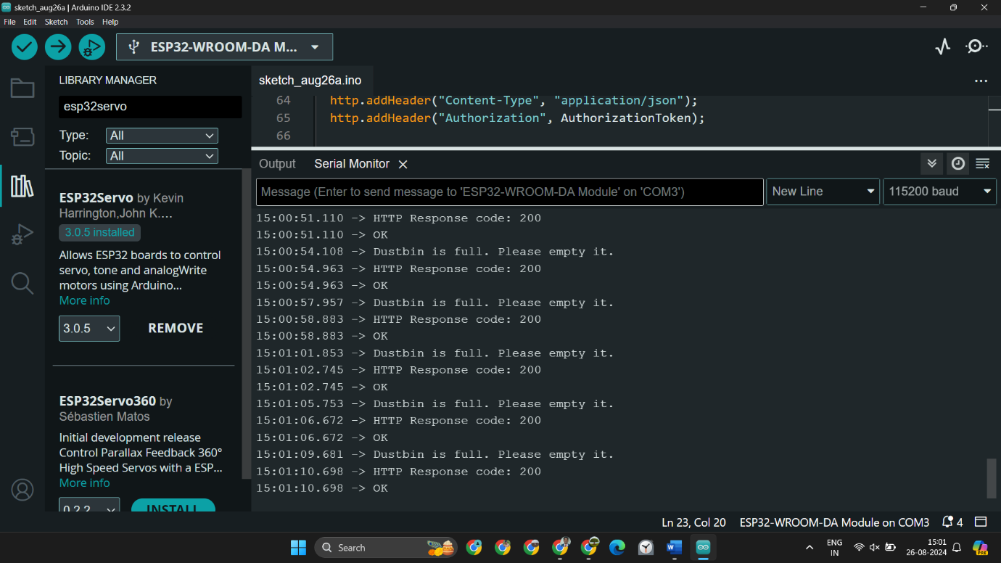

**Figure 1.5 A & B Smart Dustbin**

**CLOUD OUTPUT**

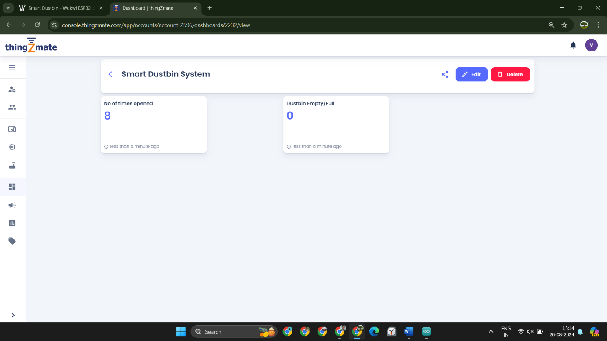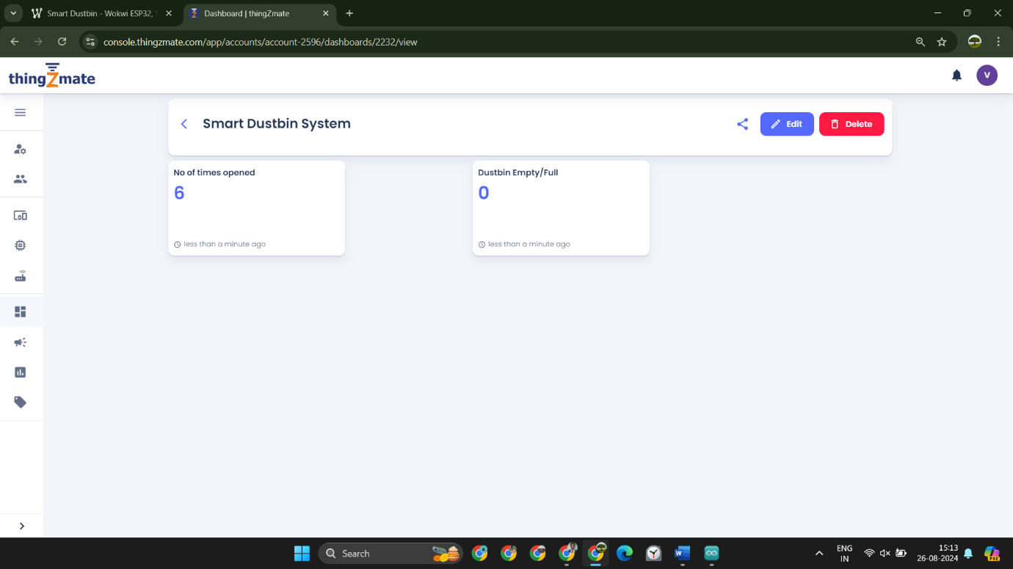

**Figure 1.6 A & B Cloud Output**

**CONCLUSION**

The Smart Dustbin System represents a significant advancement in maintaining cleanliness and hygiene in office environments. By leveraging an ESP32 microcontroller, IR sensors, and a servo motor, this system automates the process of waste disposal, making it more efficient and user-friendly. The IR sensor detects the presence of a person, triggering the servo motor to open the dustbin lid automatically, while another IR sensor monitors the fill level of the bin. This eliminates the need for physical contact, reducing the spread of germs and improving overall hygiene. Moreover, the integration of Wi-Fi connectivity and HTTP communication allows the system to send real-time data to a remote server. This data includes the number of times the dustbin has been opened and whether it is full, enabling facility management teams to monitor and manage waste disposal more effectively. This feature not only optimizes the maintenance schedule but also ensures timely waste removal, preventing overflow and maintaining a clean environment. In conclusion, the Smart Dustbin System is an innovative solution that combines automation with smart technology to enhance the cleanliness and efficiency of waste management in office spaces. Its ability to provide real-time data and hands-free operation makes it a valuable addition to modern, hygiene-conscious environments.

**REFERENCE**

1. <https://forum.arduino.cc/t/getting-max30100-sensor-values-0-in-the-local-database/1241570>.
2. <https://wokwi.com/projects/363259672680856577>
3. <https://www.taylorfrancis.com/books/mono/10.1201/9781003147169/let-get-iot-fied-shriram-vasudevan-anudeep-juluru-murugesh>
4. <https://www.electronics-lab.com/superb-open-bee-compatible-esp32/>
5. <https://www.packtpub.com/en-nz/product/internet-of-things-from-scratch-9781837638543?type=print>